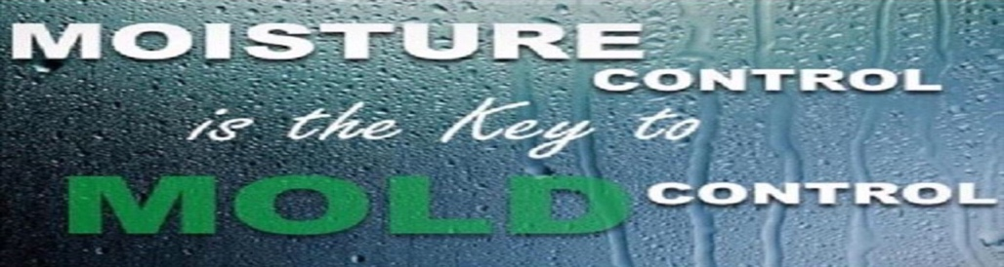
Mold Prevention:

- Purchase & change furnace filter every month of your lease agreement. Filter size is 16x25 and is available at your local hardware stores.
- When condensation does occur, dry immediately to prevent moisture build-up.
- Always run your bathroom vent fan when showering or bathing and let it run for 15 additional minutes to vent away any excess moisture.
- Run the fan above your stove while cooking and for 15 minutes after you have finished cooking.
- Cover pots and pans while cooking.
- Do not hang wet clothes inside.
- Keep apartment ventilated, run air conditioning as needed.
- Raise blinds 2” off your windows sills and open blinds.
- Move furniture, mattresses, boxes, and other belongings at least 3 inches away from walls, especially exterior walls.
- Leave closet doors open and refrain from overfilling them.
- Avoid clutter.
- Purchase a dehumidifier to remove excess moisture in your apartment if moisture or condensation continues.
- Repair fees due to damages caused by excess moisture and condensation are the tenant(s) responsibility.
- Monthly inspections and fines will apply to the tenant(s) lease ledger for failure to control excess moisture and condensation.

